Name
Class
Class no.
Date
Marks | / 50
Carmel Holy Word Secondary School
2024-2025 Term 1
Secondary 3 Computer Literacy
Practical Mock
Time: 45 Minutes

- Write your Name, Class and Class Number in the boxes provided.
- Follow the instructions below to finish the examination tasks.
- If you fail to upload your work, NO MARK will be given.

- ALL TASKS should be finished in MIT App Inventor 2.
- Login to Teams and open a folder named “S3 Term 1 Practical Mock”.
- Download the files “task1_2324.aia”, “task2_2324.aia” and “task3_2324.aia” to your computer.
- Submit your work to the suitable assignments in Teams.

Task 1 (15 marks)
Figure 1 shows the interface of Task 1.
(a) Download “task1_2324.aia” from Teams and import it into MIT App Inventor 2.
- Insert an ImageSprite on the Canvas with the following properties:
  - Name: “car”
  - Width: 30px
  - Height: 60px
  - X: 180
  - Y: 250
  - Picture: “car.png”

- Add the following blocks:
When ImageSprite "car" is being touched,
Move ImageSprite "car" upward by 10 pixels.
- Add the following blocks:
When ImageSprite "car" reached the edge,
Move ImageSprite "car" to the original position.
- Export “task1_2324.aia” and submit it to Teams.

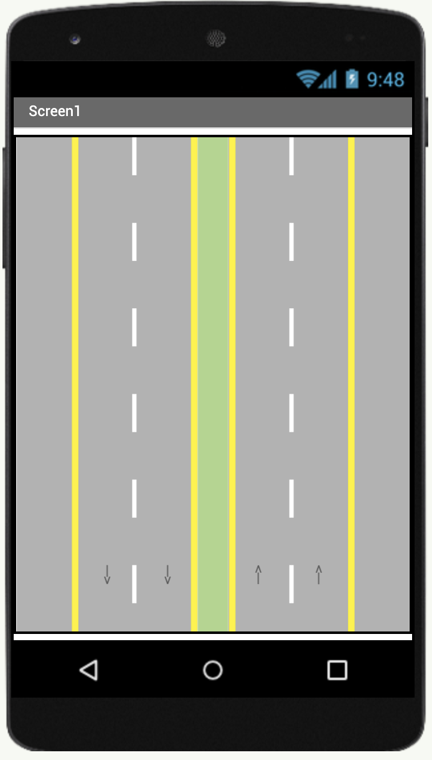

Figure 1

Task 2 (15 marks)
Figure 2 shows the interface of Task 2.
(a) Download “task2_2324.aia” from Teams and import it into MIT App Inventor 2.
(b) Add the following blocks:
When Screen1 is being initialize
Change the heading of Ball "whiteball" to random integer between 0 to 360.
Change the speed of Ball "whiteball" as 10.
(c) Add the following blocks:
When the Ball "whiteball" reaches the edge
Ball "whiteball" bounces with the edge.
(d) Add the following blocks:
When the Ball "whiteball" is being touched
Increase the text of the Label "score" by 1.
Change the heading of Ball "whiteball" to random integer between 0 to 360.
Increase the speed of Ball "whiteball" by 5.
(e) Export “task2_2324.aia” and submit it to Teams.

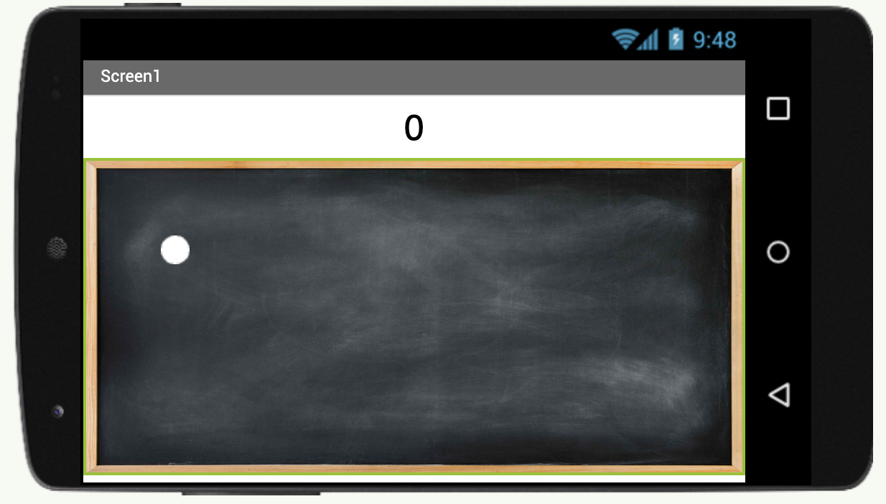
board
whiteball
score

Figure 2

Task 3 (20 marks)
Figure 3 shows the interface of Task 3.
(a) Download “task3_2324.aia” from Teams and import it into MIT App Inventor 2.
(b) Add the following blocks:
When Clock "clock" is timer tiggered
Call TeachableMachineImageClassifier "tmic" to classify video data.
(c) Add the following blocks:
When the ImageSprite "paddle" is collided with Ball "ball"
Change the heading of Ball "ball" to (0 – current heading of Ball "ball").
(d) Add the following blocks:
When the Ball "ball" reaches the edge
Ball "ball" bounces with the edge.
(e) Add the following blocks:
When the TeachableMachineImageClassifier "tmic" got classification
If the result value for "Left" is greater than "Right":
Change the heading of ImageSprite "paddle" to move left.
Change the speed of ImageSprite "paddle" to 10.
Else
Change the heading of ImageSprite "paddle" to move right.
Change the speed of ImageSprite "paddle" to 10.
(g) Export “task3_2324.aia” and submit it to Teams.
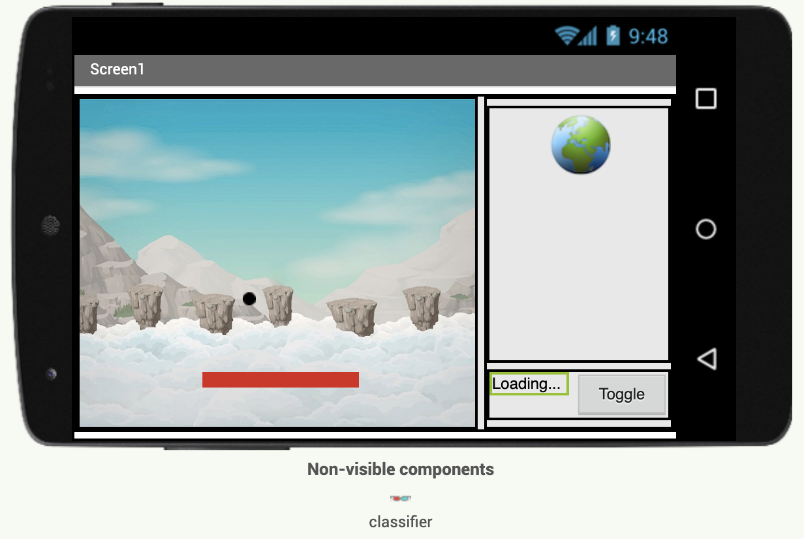

Figure 3
End of Paper

